**DECIMAL TO OCTAL CONVERSION**  
  
  
**EXP NO: 27**  
  
  
  
  
  
**AIM:**To write a C program to implement decimal  
to octal conversion.  
  
  
  
  
  
**ALGORITHM:**  
  
  
1)      Store  
the remainder when the number is divided by 8 in an array.  
  
  
2)      Divide  
the number by 8 now  
  
  
3)      Repeat  
the above two steps until the number is not equal to 0.  
  
  
4)      Print  
the array in reverse order now.

**PROGRAM:**  
#include<stdio.h>

int main()

{

int r,q,o=0,a[100];

int d,n;

printf("Enter any decimal number:");

scanf("%d",&n);

int i = 0;

while (n != 0) {

a[i] = n % 8;

n = n / 8;

i++;

}

for (int j = i - 1; j >= 0; j--)

printf("%d", a[j]);

}  
**INPUT & OUTPUT:**  
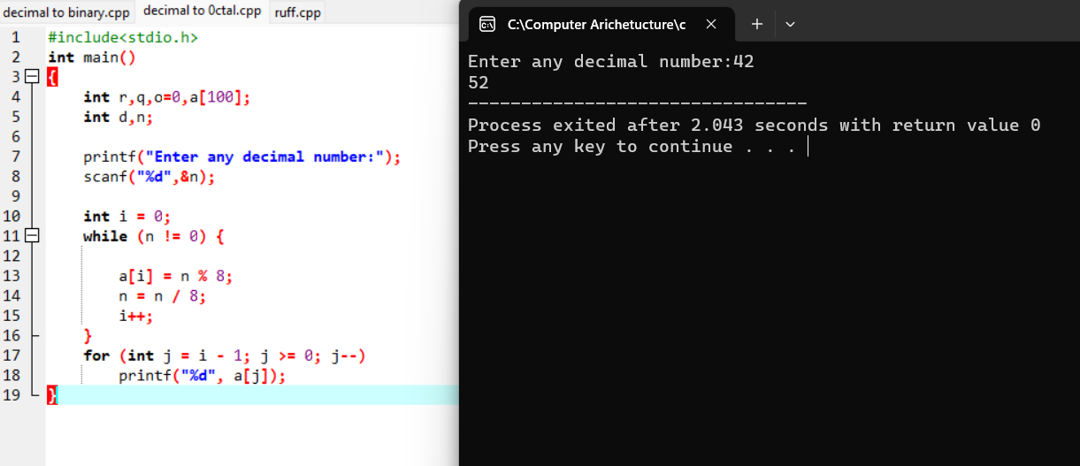  
  
  
  
**RESULT:**Thus the program was executed successfully using DevC++.